

**Freshteh mobile application**

**BY**

**Snease Mwaura**

**119824**

Submitted to the Strathmore Institute of Management and Technology in partial fulfilment of the requirements for the award of the Diploma in Business Information Technology

**Diploma in Business Information Technology**

**Strathmore University**

**December, 2023**

**Declaration and Approval**

I **Snease Wambui Mwaura** declare that this work has not been previously submitted and approved for the award of a Diploma in business information technology by this or any other University. To the best of my knowledge and belief, the proposal contains no material previously published or written by another person except where due reference is made in the document itself.

**Student Name: Mwaura Snease**

**Sign: ________________________ Date: ________________________**

**Supervisor’s Name: Fredrick Barasa**

**Sign: ________________________ Date: ______________________**

# Abstract

Good health and wellbeing aim at preventing needless suffering for all ages by improving the quality of life through health. As SDG goal, nutrition and dietetics is an integral part in realizing said goal. This is the science that focuses on everything related to food and its effect on our health and overall wellbeing. Dietitians help patients find a balance between good eating habits and exercising.

With the increasing trend in urbanization globally in general, there are less food access issues in urban than rural areas. However, this “urban advantage” does not benefit anyone who face disproportionate barriers to access healthy food.

In this case FreshTech systems will in turn solve the problem by reducing the barrier of access to healthy nutrition to low income and middle-income communities (LMIC). This is done by a mobile-based application that will enable its users to shop for proportioned ingredients from selected retailers who in turn delivers it to them via a subscription service. The site also acts as a repository on how to plan and prepare your daily nutritional needs and with premium services the user has direct access to verified dietitians who offer further guidance. An extra feature will include a way to track your deliveries.

# Table of Contents

**Declaration and Approval** v

Abstract vi

Table of Contents vii

List of tables ix

List of figures x

Chapter 1: Introduction xi

1.1 Background xi

1.2 Problem statement xii

1.3 Aim xii

1.4 Specific objectives xiii

1.5 Justification xiii

1.6 Scope and limitation xiii

1.7 Delimitations xiii

Chapter 2: Literature review xiv

2.1 Introduction xiv

2.2 Role of diet and nutrition for a healthy population xiv

2.3 Investigate challenges in obtaining healthy diet xv

2.4 Existing solutions to combat unhealthy dieting xvi

2.5 Conceptual framework xix

2.5.1 Conceptual framework introduction xx

Chapter 3: Research Methodology xxi

3.1 Introduction xxi

3.2 Iterative system development methodology xxi

3.3 System implementation tools xxiii

Chapter 4: System Analysis and design xxv

4.1 Introduction xxv

4.2 System Analysis xxv

4.3 Functional Requirements xxv

4.4 Non-functional requirements xxvi

4.5 System Analysis Diagrams xxvi

System users xxix

Chapter 5: System Implementation Testing xxx

5.1 Introduction xxx

5.2 System Implementation xxx

5.2.1 System front end xxx

5.2.2 System back end xxxiii

5.2.3 Database xxxiv

5.3 System Testing xxxiv

5.5 Test Cases xxxvi

5.6 Test results xxxvii

Chapter 6: Conclusions and Recommendations for Future Work xxxviii

6.1 Conclusions xxxviii

6.2 Recommendations xxxviii

6.3 Future works xxxviii

References xxxix

# List of figures

Figure 2 1 food stamp program xvi

Figure 2 2 Nutrisystem wight loss program xvii

Figure 2 3 Hello Fresh meal plan xviii

Figure 2 4 conceptual framework xix

figure 4.5.1 Use case diagram xxvi

figure 4.5.2 sequence diagram xxvii

figure 4.5.3 Database schema xxviii

figure 4.5 4 GUI wireframe xxix

xxx

Figure 5.1 Sign up page xxx

Figure 5.1 code snippet for sign up page xxxi

Figure5.1 code snippet for sign up page xxxi

Figure 5.1 Log in page xxxii

Figure 5.1 Code snippet for log in page xxxii

Figure 5.2 Code snippet for browse page xxxiii

Table 5.5 Test cases xxxv

Table 5.6 Test results xxxvi

# Chapter 1: Introduction

### 1.1 Background

Poor diet and nutrition are among the leading causes of global illness, disability and death (national library of medicine, 2021). Deaths caused by non-communicable diseases (NCD) in low income and middle-income communities (LMIC) are proportionally higher than in high income communities (HIC) in urban settings. This is as a result of their food environment. Food environment includes; physical, economic, policy, cultural surrounding which affects dietary behavior, nutrition and health.

With the rapid emergence of global trade and urbanization, food environments are becoming homogenous. 55% of the global population live at urban settings and this figure is projected to rise to 70% by 2050 (national library of medicine, 2021). There is evidence that diets, dietary behavior and related health outcomes may be poorer in urban LMIC settings than in rural LMIC settings.

 High cost of living becomes a challenge for people in poor communities which not only they cannot access proper healthcare services but their nutritional needs are ignored. In that case, they cannot exercise preventative measures against certain diseases. Most of these diseases hinder people from becoming economically productive hence cannot escape the poverty trap which is also another SDG goal of eradicating poverty. These challenges have been addressed in the Sustainable Development Goals specifically, SDG 11 establishes that countries need to have urban sustainable development plans to promote the wellbeing of people, especially the most socioeconomic vulnerable

An example of concerning dietary behavior is; urban residences are more likely to consume more salt and less vegetables.  A 2015 study of 74 Latin American countries found that sales of ultra processed products were larger in more urbanized countries as the market expands towards poorer areas (pan african health organization, 2019). Ultra-processed products have a high energy density, long shelf lives, ready-to-eat and they are relatively cheaper.

There has been a semi-solution in regards to this with emergence of delivery services, fast food and dinner restaurants that also provide their own delivery services. Examples include Uber eats, Glovo, Hellofresh, pizza Inn etc. Some deliver ready cooked meals while some provide pre-portioned ingredients. Aspects that emerged from the problem are strategies used by the urban poor to obtain food are the use of food banks and community kitchens. These studies found that beneficiaries considered such support strategies valuable but insufficient to fully mitigate hunger and lack of access to food, hence, families and individuals need other coping mechanisms like selling food on the streets to generate income, while at the same time have more access to food. Other strategies implied skipping meals or eating smaller portions.

Freshtech systems will take the already existing systems to another level by connecting average consumers to dietitians who can help in monitoring and guiding their dietary behaviors.

### 1.2 Problem statement

If food environment of lower- and middle-income urban communities is left unchecked, this will result into poor health of its population. Organizations/researchers involved with public health are unable to regulate non-communicable diseases because they cannot monitor its population food environment and eating habits. This leads to an increase in lifestyle diseases such as cancer, kidney failures and diabetes. Patients who already suffer from such diseases rely on visiting health centers for assistance which in turn may overwhelm the medical sector.

People living among lower and middle income (LMIC) settings are unable to detect such diseases nor take preventative measures against them. This is due to they cannot afford certain medical services or lack the knowledge to do so. Eventually, this lowers productivity and mortality of said population.

### 1.3 Aim

Freshtech mobile application aims at reducing time and costs in planning, gathering and preparing one’s meal on a daily basis. It also enables the user to monitor one’s health by keeping in check one’s eating habits. This is done by connecting average users to more verified medical professionals who in turn guide them in their eating habits and exercise behaviors.

It also aims at improving the general knowledge of its users by proving a well-researched repository of all things concerning health and diet. With a reliable delivery system, users can also receive proper meals at their own convenience.

### 1.4 Specific objectives

1. To investigate the role of diet and nutrition for a population’s health and wellbeing.
2. To investigate challenges in obtaining proper diet and nutrition.
3. To review existing solutions put in place.
4. To develop a system that will advance existing solutions.
5. To test the proposed system solution.

### 1.5 Justification

The proposed solution will improve the accessibility of more nutritionally rich foods which are more common in high-incomed areas to poorer areas. It will also allow monitoring of one’s state of health through what they eat and direct access to medical personnel. Through this looking after one’s state of being will be more affordable and less time consuming.

Furthermore, this will decrease the consumption of processed foods which have been highly discouraged by researchers related to public health. Freshtech will also create employment opportunities such as; transportation services, supply of various food items and also need for more medical practitioners.

### 1.6 Scope and limitation

The system aims at allowing users to shop, track their deliveries, communicate to a dietitian and gain more knowledge on one’s dietary behavior. The system will store all the data purchases done so that dietitians will be able to make a more accurate diagnosis based on one’s consumption.

However, the system will not be able to conduct tests on one’s body hence users are advised to visit health centers for more accurate diagnosis. Another system limitation is that users will not be allowed to place orders on a daily basis due so as to overwhelm transportation and system functionalities.

### 1.7 Delimitations

Whereas daily delivery might overwhelm the system, users will be advised to purchase in bulk upto three times a week. This will also save on fuel consumption thus making it environmentally friendly.

# Chapter 2: Literature review

### 2.1 Introduction

This chapter goes in-depth on how to solve this project’s objectives through collecting relevant research data. It details the capabilities of the system and gives a clear outline of its objectives.

### 2.2 Role of diet and nutrition for a healthy population

#### 2.2.1 Increased mortality

Certain dietary changes have been associated with longevity. The researchers brought together data from many studies that looked at diet and longevity which provides a summary of population health from many countries. Combining this data, the authors were then able to estimate how life expectancy varied with continuous changes in intake of fruit, vegetables, whole grains, refined grains, nuts, legumes, fish, eggs, dairy, red meat, processed meat and sugary drinks. They found that eating an optimal diet from age 20 would increase life expectancy by more than a decade for women and men. (world economic forum, 2022)

#### 2.2.2 Reduced risk of chronic diseases

Some of the diseases are; heart disease, stroke, diabetes, obesity, metabolic syndrome, chronic obstructive pulmonary disease, and some types of cancer. They are non-communicable hence there is no physical way controlling the rapid increase unless you treat every individual. Chronic diseases may result in loss of independence, years of disability and even death. 61 per cent of all deaths -- 35 million -- and 49 per cent of the global burden of disease were attributable to chronic diseases. By 2030, the proportion of total global deaths due to chronic diseases is expected to increase to 70 per cent and the global burden of disease to 56 per cent (united nations) . Adoption of a healthy diet seems to be associated with as much as an 80 per cent reduction in the risk of developing the most common and deadly chronic diseases.

#### 2.2.3 Good for the environment

The world’s food systems generate [one third of all greenhouse gas emissions](https://www.nature.com/articles/s43016-021-00225-9) (warrell, 2023). This is partly because of agriculture – but also because of the carbon impacts of processing, refrigeration, and transportation. [Research has shown](https://www.soilassociation.org/blogs/2022/august/24/how-bad-is-ultra-processed-food-for-the-planet/) that ultra-processed foods are linked to more greenhouse gases than other food groups. Thus, the system aims at reducing the over reliance of processed foods. Reduced carbon emissions help in controlling pollution which is known to have negative effects to one’s health and wellbeing.

### 2.3 Investigate challenges in obtaining healthy diet

#### 2.3.1 Lack of time

Scarcity of time often results in fewer opportunities to prepare meals at home, leading to an increase in fast food consumption and fewer family meals. This can lead to an overall less healthful eating pattern with unintended health consequences. This is due to the fact that their lifestyle demands a lot of their time dedicated to their careers or businesses hence they fail to monitor their nutritional needs. Some even lack time to outsource healthier food options which are not available in their area.

#### 2.3.2 Financial strain

People in low-income communities and some racial and ethnic groups often lack access to convenient places that offer affordable, healthier foods. (center of disease control and prevention). Some of these areas have limited supply of resources such as health professionals or agricultural resources to boost food security. Families in low-resource areas may find healthcare to be cost-prohibitive, including appointment fees, transportation costs, and loss of wages while seeking care. Adding to the affordability equation, the expense of a nutritious diet may contribute to food insecurity or food shortages among the most nutritionally vulnerable (barriers to access).

#### 2.3.3 Limited awareness

Interventions and services may be available, but families do not know they exist or why they are needed (barriers to access). It is well accepted that a higher level of nutrition knowledge contributes to promoting healthier dietary behaviors, while a lower level of nutrition knowledge is closely related to poor eating habits, unbalanced dietary patterns and a higher risk of nutrition-related chronic diseases. Time constrain may also hinder people from conducting more research regarding to their personal wellbeing hence end up being aware of their unhealthy habits once they start experiencing consequences such as chronic diseases.

### 2.4 Existing solutions to combat unhealthy dieting

#### 2.4.1 Supplemental nutrition assistance program (SNAP)

Formerly known as the Food Stamp Program, is a [federal government](https://en.wikipedia.org/wiki/Federal_government_of_the_United_States) program that provides food-purchasing assistance for [low- and no-income people](https://en.wikipedia.org/wiki/Poverty_in_the_United_States) to help them maintain adequate [nutrition](https://en.wikipedia.org/wiki/Nutrition) and [health](https://en.wikipedia.org/wiki/Health). It was introduced in the US during the great recession then later declined as the economy recovered. The amount of SNAP benefits received by a household depended on the household's size, income, and expenses. However, several recent reports have raised concern that SNAP benefits are too low because they do not take into account; geographic variation in food prices, cost variations associated with the age and nutrient requirements of household members and the costs of time spent in food preparation.

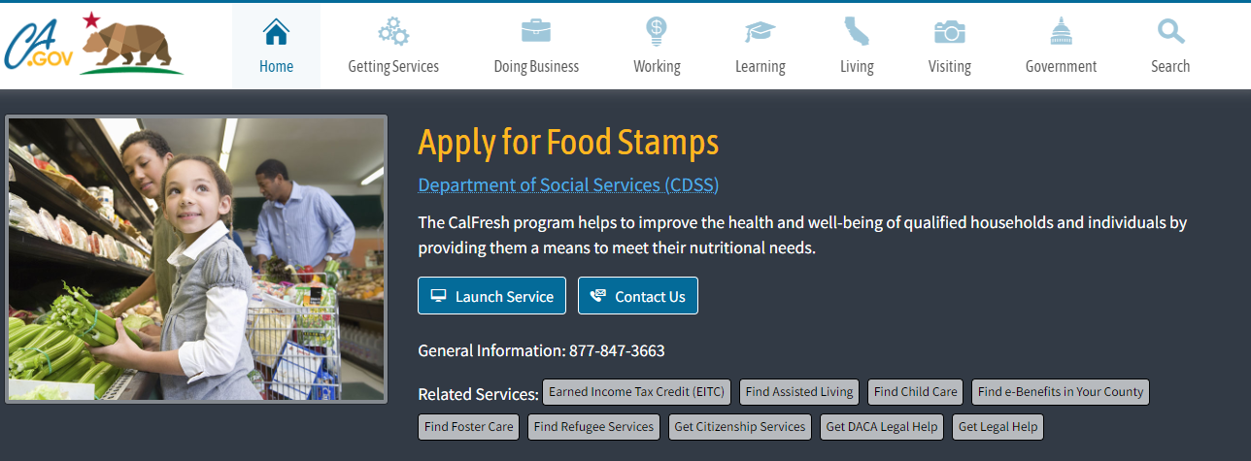Figure 2 food stamp program

#### 2.4.2 Diet programmes

These structured programs offer support for dieters that could include in-person or online coaching and support, books, packaged foods, bars or drinks that help members follow the diet plan. Additional support and resources may include food tracking apps, meal plans and recipes. Self-discipline is described as both an enabler of and a barrier to dietary change.

All studies reported that patients often described the challenge of trying to resist food they wanted to eat but knew wasn’t healthy, eat food they knew was healthy but didn’t enjoy, and reduce portion sizes (National library of medicine, 2013). This is because consumption of particular foods was linked to identity and belonging. Some papers suggested that stress might trigger consumption of unhealthy “comfort” foods. (National library of medicine, 2013)

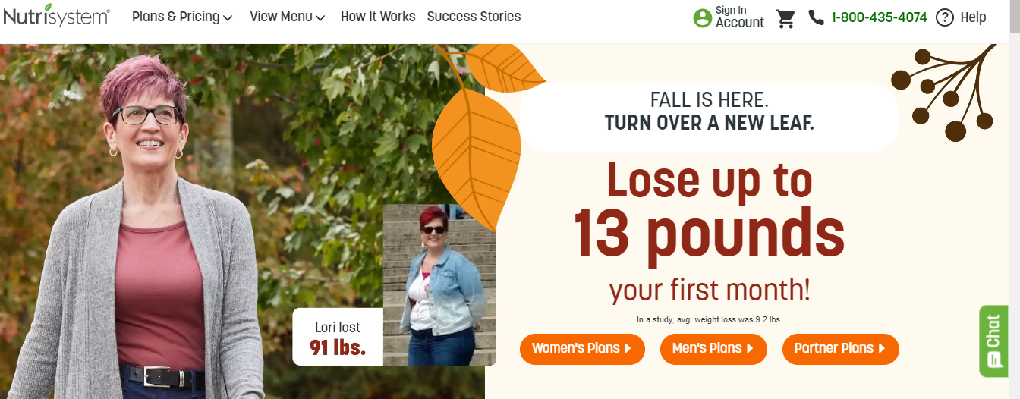

Figure 2 Nutrisystem wight loss program

#### 2.4.3 Meal kit delivery services

A meal kit is a [subscription food service](https://en.wikipedia.org/wiki/Subscription_service) [business model](https://en.wikipedia.org/wiki/Business_model) where a company sends customers pre-portioned and sometimes partially-prepared food ingredients and [recipes](https://en.wikipedia.org/wiki/Recipes) to prepare home-cooked meals. The consumer therefore makes a choice of their meals from diverse weekly menu, including low carb & veggie options. Team of chefs then prepare the fresh ingredients based on the requirements of the customer’s order. Lastly a delivery is made.

Benefits include; reduced time in gathering and preparing meals, ease of boredom since there is a variety of recipes, users can try new foods and one can know what they eat since they are involved in preparing their meals.

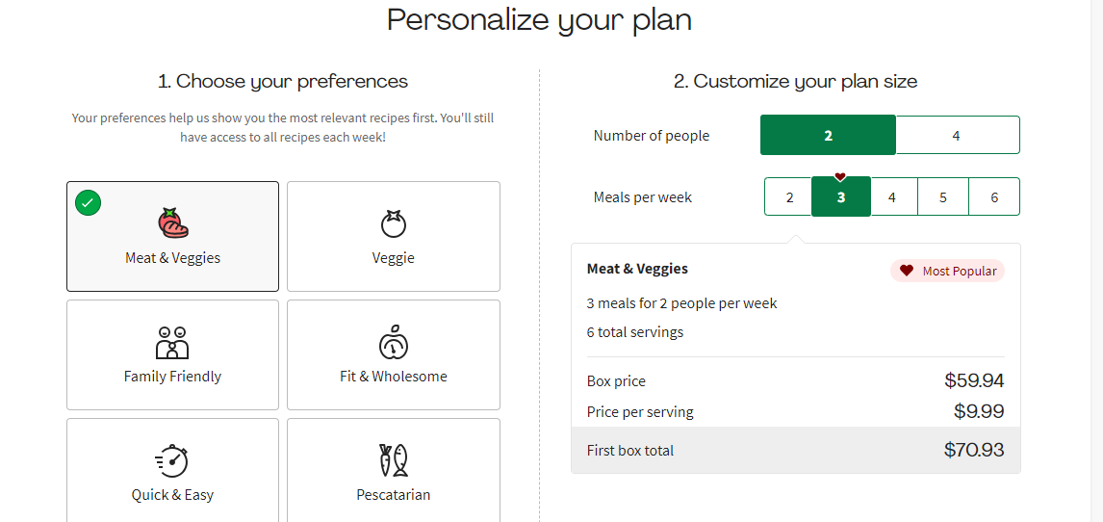

Figure 2 Hello Fresh meal plan

### 2.5 Conceptual framework



[This Photo](https://stackoverflow.com/users/5855374/linuxartisan) by Unknown Author is licensed under [CC BY-SA](https://creativecommons.org/licenses/by-sa/3.0/)

User makes an order from local supermarket

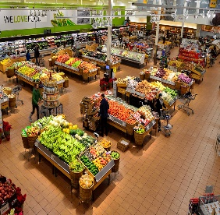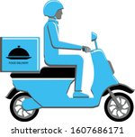

Retail receives order information from users

Retailer sends delivery Information to transport service providers

User tracks delivery

Dietitian provides feedback to user and posts recommendations to system

User logs/registers

User receives feedback from dietitian, delivery information, meal recommendations

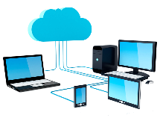

[This Photo](https://www.pngall.com/networking-png/) by Unknown Author is licensed under [CC BY-NC](https://creativecommons.org/licenses/by-nc/3.0/)



[This Photo](https://courses.lumenlearning.com/wmopen-nmbiology1/chapter/putting-it-together-dna-structure-and-replication/) by Unknown Author is licensed under [CC BY](https://creativecommons.org/licenses/by/3.0/)

Figure 2 4 conceptual framework

### 2.5.1 Conceptual framework introduction

A conceptual framework is a representation of the relationship you expect to see between your variables, or the characteristics or properties that you want to study. The variables include the customer, dietitian, retailer and delivery. However, the delivery section does not necessarily interact directly with the system but delivery details are needed in the software.

1. Customer

Once the customer creates an account, he/she is able to receives feedback from dietitian, delivery information, meal recommendations, payment confirmations and has access to the repository.

1. Retailer

Once a retail dealer is registered into the system, they are able to display their meal packages, receive orders, confirm the payment and issues delivery information to the customer.

1. Dietitian

Once the dietitian creates a profile, they are able to receive user requests and offer feedback to them.

# Chapter 3: Research Methodology

### 3.1 Introduction

Object-oriented analysis and design (OOAD) approach is going to be used. The reason is due to it breaks down the problem into small units called objects that can stand on their own and can be changed without affecting the ones around them too much. This chapter will cover the procedures taken during the development, design, and implementation of the system. It will also discuss the tools and techniques to be used and the outcomes to be expected.

The project is specifically going to use an iterative software development life cycle

### 3.2 Iterative system development methodology

The iterative methodology is a way of developing a product or service in phases, with each phase building on the previous one. The key advantage of this method is that you can test your ideas early and often hence less wasted time, money and resources later on when it comes to implementing your system. The iterative methodology is a process of gradual improvement, learning from the previous iteration how to improve the next.

In this incremental model, the whole requirement is divided into various builds. During each iteration, the development module goes through the requirements, design, development, implementation and testing phases. Each subsequent release of the module adds function to the previous release. The process continues till the complete system is ready as per the requirement.

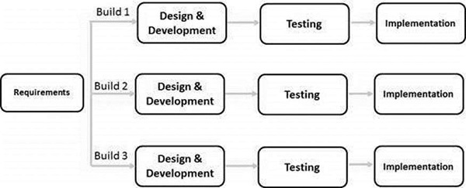

#### 3.2.1 Planning and Requirements engineering

Requirement elicitation techniques such as interviews, questionnaires, joint application and development will be crucial in collecting requirements in this phase. The project requirements will be gathered and fully understood up front. Documents or resources related to the project will be gathered where a plan is created and a timeline for the first iterative cycle is made. Initial planning stages would also be used to generally prepare for the next upcoming stages of the cycle.

#### 3.2.2 Analysis and design

In this phase we will decide how to build the system. We will mainly focus on the physical design which has to do with how the requirements of the system are satisfied. To sum it all up system design is the determination of the overall system architecture. Hereby the system architecture will be represented by data flow diagrams DFDs. DFDs illustrate how information flows between various system functions and demonstrate the current implementation process of the system. They also summarize what information the system processes, which transformations it performs, where it stores data, what result it produces and where those results go.

#### 3.2.3 Development and implementation

This involves bringing to life what you designed during the design phase. Here coding starts using a programming language of choice and since it is iterative it is done in increments each iteration is coded and tested before the next iteration. Java was thus the programming language used.

#### 3.2.4 Testing

This will help to ensure a good user experience. The testing team will in turn design documents and user case scenarios supplied by the project manager to create their test cases. The procedures help us identify and locate any potential bugs or issues that might have cropped up. Identifying what’s not working or performing to expectations takes place. The users and product testers weigh in with their experiences.

### 3.3 System implementation tools

Tools used for implementation include;

1. Android Studio - provides app builders with an integrated development environment optimized for Android apps and also it is free.
2. JavaScript was used as the programming language.
3. Intel HAXM – is an SDK that allows java code on android studio to run on an Android Virtual Device (AVD) on windows.
4. DB browser for SQLite – for looking for SQL files for the app
5. Vysor – is an application that enables users to share IOS and android screens on desktop

#### 3.4 Deliverables

This explains the system's development process as well as the completion deadlines for the various milestones. It also provides an estimate of when the system will be ready. It depicts the process of putting the system in place.

#### 3.4.1 Design Diagram

The first system deliverables are the design diagrams. These diagrams represent how the system works, how the flow of information in the system is achieved and what triggers certain actions in the system. The diagrams will be used as a blueprint on developing the software. The design diagrams will be completed by 21/10/2023

#### 3.4.2 Database connectivity

The system is connected to a database to ensure that all the information the entities that will be interacting with the system such as the users, dietitians, retail outlets and delivery service providers will be stored safely in the database and they can be easily retrieved whenever they are needed. The database connectivity will be completed by 23/10/2023

#### 3.4.3 Admin module

The admin is a single user who determines whether the user can view specific information that has been stored in the database. He or she has access to all information. The admin module will be completed by 25/10/2023

#### 3.4.4 User interface

This will include what the users of the system will see on their end. We developed this using a GUI. The user interface will be completed by 5/11/2023

#### 3.4.5 Security and authentication

This user module will allow a user to key in their details and once authorized by the admin they can proceed to log in. This will be completed by 15/11/2023

#### 3.4.6 System documentation

Refers to the collection of documents that describes the requirements, capabilities, limitations, design, operation and maintenance of a system such as communications and computing. The system documentation will be completed by 7/12/2023

# Chapter 4: System Analysis and design

### 4.1 Introduction

This chapter deals with the analysis and design of the system development life cycle. A feasibility analysis was carried out and design diagrams are also included. This chapter also describes the structure and behaviour of the system by representing data flow, inputs and outputs of the system through modelling. Use case diagram, class diagram, sequence diagram, ERD diagram and database schema was used.

### 4.2 System Analysis

This system uses the process of Object-Oriented Analysis and Design (OOAD) which is a technical approach for analysing, designing, and building a system by using visual modelling throughout the software development process.

### 4.3 Functional Requirements

Functional requirements define the basic system behaviour. Essentially, they are what the system does or the services that the system delivers.

The requirements delivered by this system were as follows:

i. New users which include dietitians are able to create a profile through registration.

ii. The system will allow uses to make and order and make payment to selected retailers.

iii. User is able to track deliveries.

iv. User is able to communicate to dietitian

v. Dietitian is able to provide feedback to user.

vi. Existing users are able to log into the system.

### 4.4 Non-functional requirements

Non-functional requirements define system attributes such as security, reliability, performance, maintainability, scalability, and usability.

1. Performance - defines how fast a software system responds to certain users’ actions under a certain workload.
2. **Compatibility** - defines how a system can coexist with another system in the same environment.
3. **Reliability -**specifies how likely the system would run without a failure for a given period of time under predefined conditions.
4. Security – assures all data inside the system will be protected against malware attacks or unauthorized access.
5. Usability – defines how easy is the system for its users to use.

### 4.5 System Analysis Diagrams

#### 4.5.1 Use case diagram

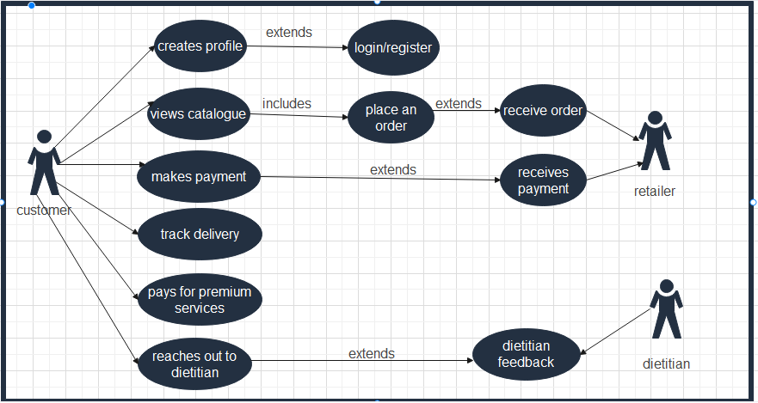

figure 4.5.1 Use case diagram

#### 4.5.2 Sequence diagram

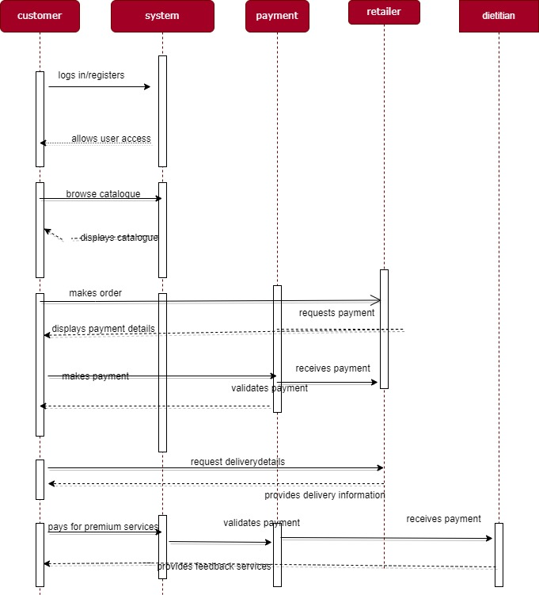

figure 4.5.2 sequence diagram

#### 4.5.3 Database schema

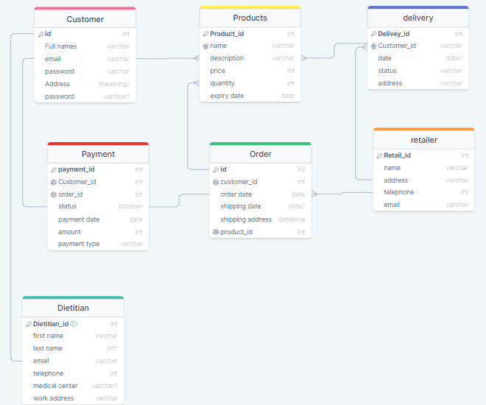

figure 4.5.3 Database schema

#### 4.5.4 GUI wireframe

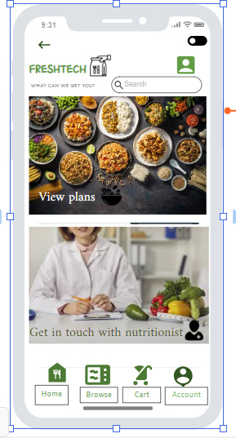

figure 4.5 4 GUI wireframe

### System users

1. Customer –Creates a profile, logs in, view catalogue, make an order, make payment, track delivery
2. Administrator- can view database,
3. Retailer – creates an account receives order, confirms payment
4. Dietitian- Creates account,

# Chapter 5: System Implementation Testing

## 5.1 Introduction

System Implementation Testing generally refers to the process of testing implementations of system specifications. This process serves the purpose of verifying that the specification is implementable in practice, and that implementations conform to the specification. It also helps to improve the quality of implementations. This chapter proposed to describe the way the system was developed along with the tests done on it.

## 5.2 System Implementation

The app was implemented using android studio which has an inbuilt AVD and SDK tools. Java programming language was used. For the database DB browser for SQLite, an open-source tool was used to create, design and edit database files. The register and login pages were developed first for authentication of email and password, after which the bulk of the system was created. In order to view the app on an android device Vysor was used to display the android screen on desktop.

### 5.2.1 System front end

The system’s front end consists of the logic behind creating the user interface which consists of the sign-up page, log in page, dashboard and checkout page

1. Sign up page

The below screenshot shows how the user interface for the sign page was designed.

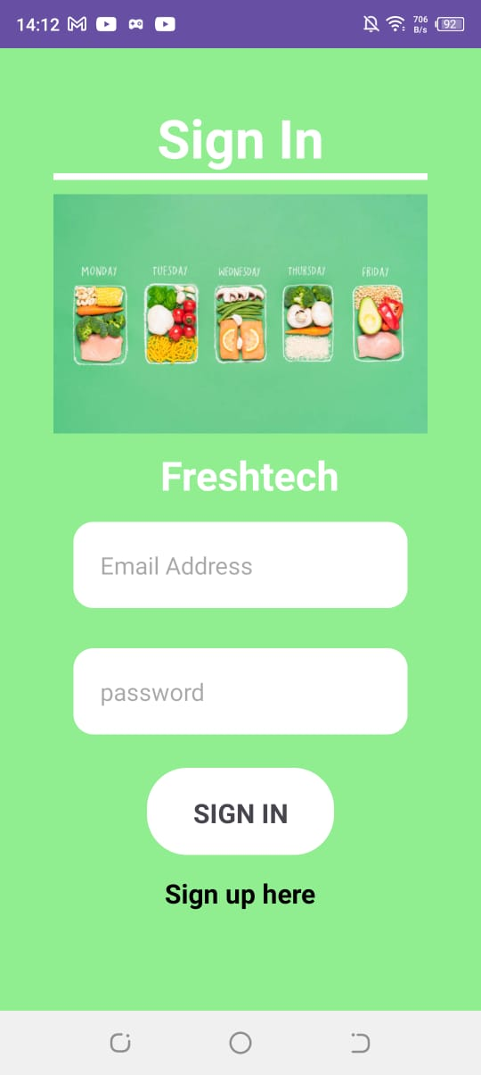

Figure 5.1 Sign up page

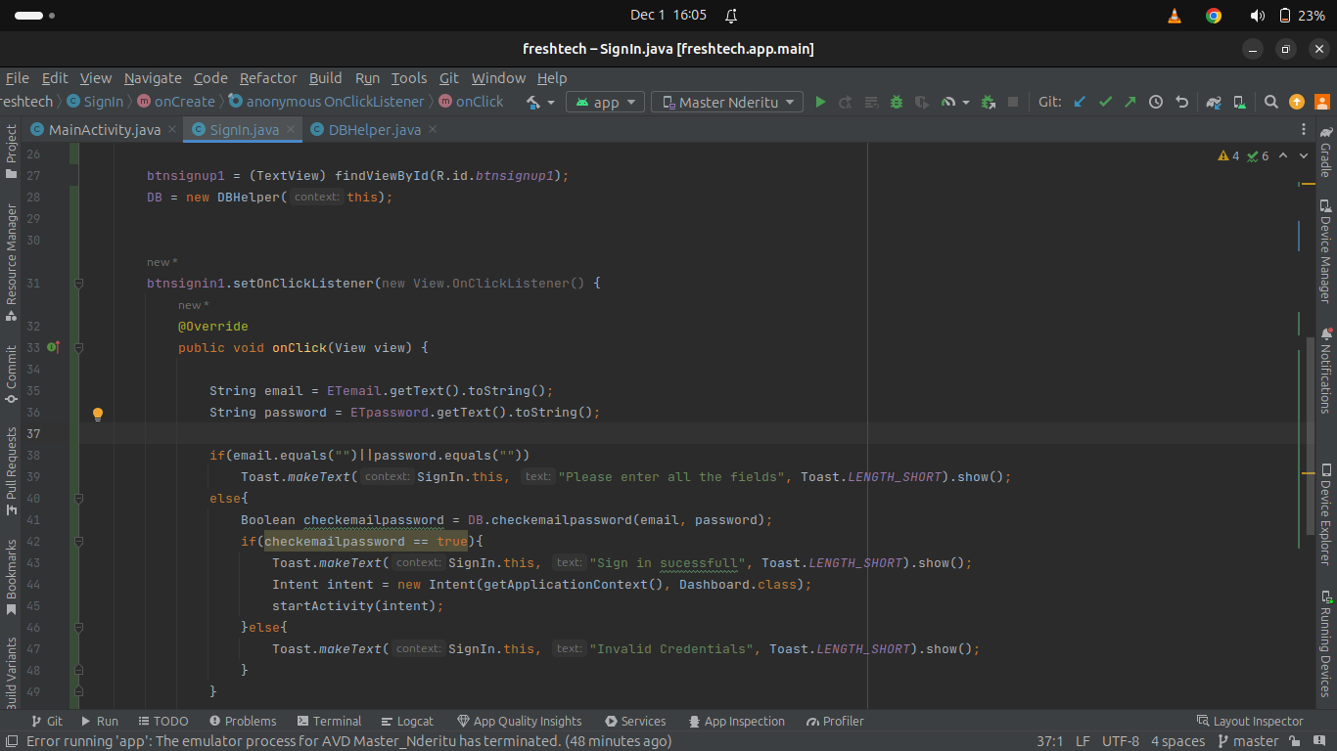

Figure 5.1 code snippet for sign up page

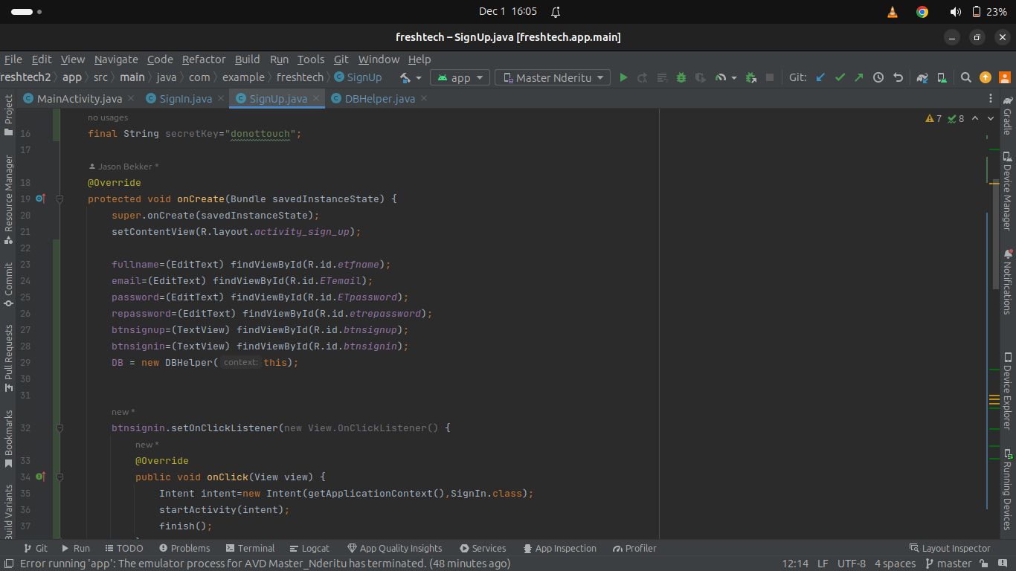

Figure5.1 code snippet for sign up page

1. Log in page

Below is a screen shot of how the log in page interface was designed

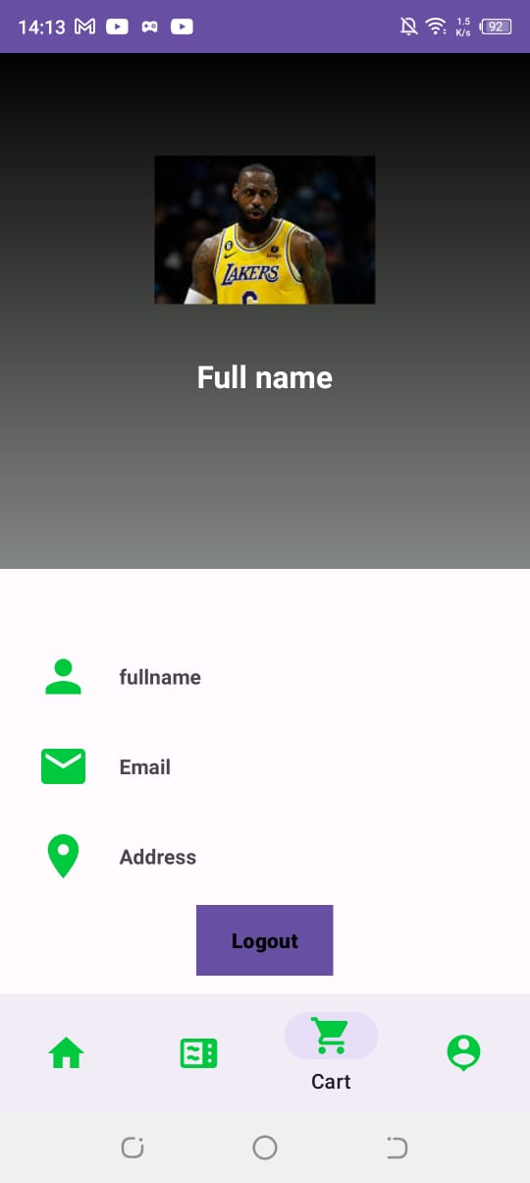

Figure 5.1 Log in page

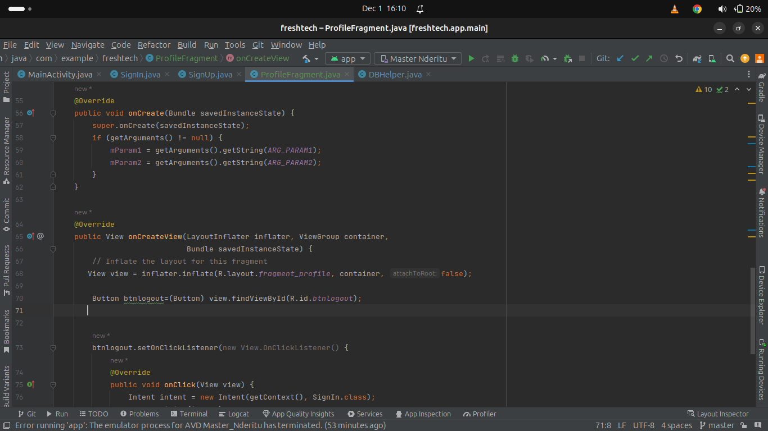Figure 5.1 Code snippet for log in page

### 5.2.2 System back end

The system’s backend comprises of the logic behind the main functionalities of the supply chain management system as shown below.

1. Login sessions

The below screenshot shows the user types of each user in the system and how they are redirected to their specific home pages after a successful login. So far, it’s the customer log in session

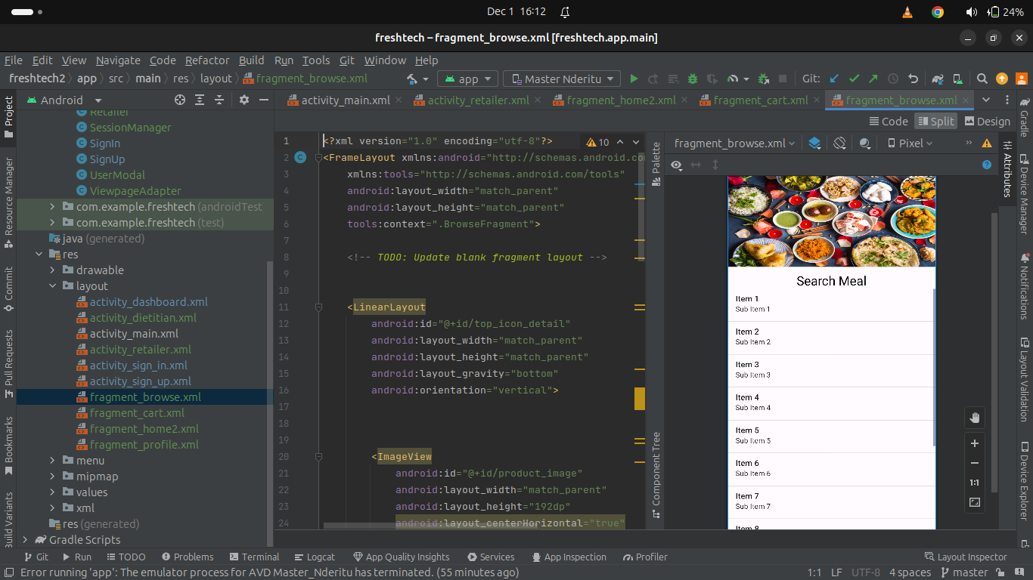

Figure 5.2 Code snippet for browse page

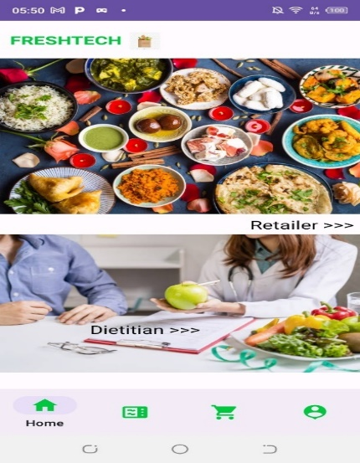

### 5.2.3 Database

DB browser for SQLite, an open-source tool was used to create, design and edit database files. The register and login pages were developed first for authentication of email and password, after which the bulk of the system was created.

## 5.3 System Testing

This section focuses on the system, what it does and whether the requirements of the system have been met. The testing assists in the detection of system failures and defects which allowed for their rectification.

#### 5.3.1 Blackbox testing

Black Box Testing was used on the system to check the usability of the system from the user’s point of view. The system was developed by keeping in mind the idea of having an interactive user interface with color related to healthy nutrition. The interface is low in complexity.

#### 5.3.2 Unit testing/ Functionality testing

Unit testing is a kind of testing where the individual units or functions of the system are tested. The system satisfies all the functional requirements by allowing users to create their own account and allowing only authorized users to log into the system. The app installs and launches correctly as the textbox and buttons function correctly.

#### 5.3.3 Device testing

This is ensuring the quality of hardware used to display the application provides an optimal environment for the system to run e.g., the app is swiping and dragging as expected

### 5.5 Test Cases

|  |  |  |  |
| --- | --- | --- | --- |
| Test Case # | Description | Test Data | Expected Outcome |
| Registration test | Register by filling all the empty fields  Register without filling all the empty fields | Requested user information | Registration successful  Registration not successful |
| Log in test | Log in with right credentials  Log in with wrong credentials | Email and password | Successful authorization  Log in not successful |
| View product | Browse for items | Listed items/plans/ categories | Meal plans are visible |
| Check out | Submit cart to check out | Cart items | Should request payment method and details  Retailer should receive notification of items ordered |
| User -dietitian communication  Dietitian to user communication | Send message to dietitian  Sends message to user | Content of message  Content of message | Dietitian module should receive full message content  User should receive full message content |

Table 5.5 Test cases

## 5.6 Test results

|  |  |  |  |  |  |
| --- | --- | --- | --- | --- | --- |
| Test Case # | Description | Test Data | Expected Outcome | Actual Result | Verdict (Pass or Fail) |
| Registration test | System accepts correct user information | Full name  Email address  Password  Confirm password | Successful registration | Registration successful | pass |
| Log in test | System authorizes correct user inputs | Email address  password | Successful log in | Log in successful | pass |
| View product | Customer can browse visible items | Visible items | User can select and submit product to cart | Selection successful | pass |
| Check out | Customer submits cart to check out | Selected items | Submission successful | No payment request initiated | Fail |
| User- dietitian communication | Customer can initiate and receive messages from dietitian | Message content | Communication successful | Communication not successful | fail |
| Dietitian user communication | Dietitian can receive and send messages to customer | Message content | Communication successful | Communication unsuccessful | fail |

Table 5.6 Test results

# Chapter 6: Conclusions and Recommendations for Future Work

## 6.1 Conclusions

The application aimed at improving accessibility to healthier alternatives of nutrition through a meal plan subscription service. There seemed to be a problem of planning gathering and preparing a healthy meal on a daily basis. This is due to the fact of limited time, limited knowledge and high cost implications.to review these problems, the developed system solves the stated problems contrary to previous stated solutions in chapter 2.

## 6.2 Recommendations

For the mobile application to run smoothly, a compatible Android device that runs Android 5.0 (API level 21) or higher and has the Google Play Store app installed is needed. The Android emulator with an AVD that runs the Google APIs platform based on Android 5.0 (API level 21) or higher. It's the fastest Android option, most adaptable, and most customizable. Blue stacks is another alternative for testing the application.

## 6.3 Future works

Additional system functionalities will be added such as tracking feature which will enable customers to keep track on their deliveries. The system can also be improved by adding strong authentication processes such as checking password lengths, two-factors authentication to heavily protect all user’s (customer, dietitian and retailer) data and the application’s data. Incorporation of AI technology may be implemented to automate the whole process so as to attain the likelihood of offering delivery services daily. Another feature is to link FreshTech with an online mobile payment system’s API to allow smooth monetary transactions. Also the implementation of dietitian and retailer module will be done in future

# References

al, f. e. (2001).

al, l. e. (2009).

*barriers to access.* (n.d.). Retrieved from vitaminangels.org: https://vitaminangels.org/why-we-exist/challenges/barriers-to-access/

center of disease control and prevention. (n.d.). *poor nutrition.* Retrieved from cdc.org: https://www.cdc.gov/chronicdisease/resources/publications/factsheets/nutrition.htm#:~:text=People%20in%20low%2Dincome%20communities,their%20risk%20of%20chronic%20diseases.

kerr, j. a. (2005).

*National library of medicine*. (2013, september). Retrieved from How Diet Modification Challenges Are Magnified in Vulnerable or Marginalized People With Diabetes and Heart Disease: https://www.ncbi.nlm.nih.gov/pmc/articles/PMC3817924/#:~:text=Five%20themes%20were%20identified%20as,the%20social%20significance%20of%20food.

*national library of medicine*. (2021, October). Retrieved from National center for biotechnology information: https://www.ncbi.nlm.nih.gov/pmc/articles/PMC8506857/#:~:text=In%20urban%20LMIC%2C%20individuals%20are,as%20more%20expensive%20fresh%20food.

organisa, U. (n.d.). *unicef data: monitoring the situation gor women and children*. Retrieved from data.unicef.org: https://data.unicef.org/sdgs/goal-3-good-health-wellbeing/#:~:text=Ensure%20healthy%20lives%20and%20promote%20well%2Dbeing%20for%20all%20at%20all%20ages&text=Goal%203%20aims%20to%20ensure,life%2C%20starting%20from%20the%20beginning.

pan african health organization. (2019). Retrieved from paho: https://scholar.google.com/scholar?q=Pan+American+Health+Organization+.++Ultra-processed+food+and+drink+products+in+Latin+America:+sales,+sources,+nutrient+profiles,+and+policy+implications:+pan+American+health+organization+(PAHO)++2019+;+72+.+

reject. (2018). Retrieved from https://reject.awcfs.org/article/nakuru-gk-prison-in-crisis-due-to-overcrowding-in-cells/

rodriguez, m. a. (2007).

*united nations.* (n.d.). Retrieved from un.org: https://www.un.org/en/chronicle/article/lifestyle-diseases-economic-burden-health-services

warrell, e. (2023, february 28). *wicked leaks.* Retrieved from https://wickedleeks.riverford.co.uk/features/how-does-processed-food-harm-the-environment/#:~:text=The%20world's%20food%20systems%20generate,gases%20than%20other%20food%20groups.

wikipedia. (n.d.). *community gardening.* Retrieved from en.wikipedia.org: https://en.wikipedia.org/wiki/Community_gardening

*world economic forum.* (2022, feb). Retrieved from weforum.org: https://www.weforum.org/agenda/2022/02/diet-life-expectancy-lifespan-healthy-eating/